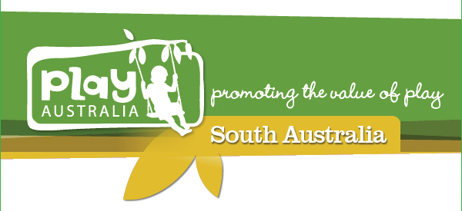

Would you like to help shape the future of play provision in South Australia?
Call for Expressions of Interest –
Play Australia South Australia Committee Members

If so, Play Australia South Australia (PASA) will be declaring 4 positions vacant for its Committee at the upcoming AGM.

Play Australia South Australia was created in 2014 as a branch of PLAY AUSTRALIA.

PLAY AUSTRALIA is committed to promoting the value of play and increasing play opportunities for children, young people and families.

PLAY AUSTRALIA promotes the value of play and advocates healthy play opportunities for children and the community throughout Australia.

Play Australia is seeking members from any sphere of government, health, risk, early childhood, suppliers, designers or manufacturers.

To be eligible you must be:
- A current financial member
- Committed to participate in Play SA committee meetings
- Commit to discharge the roles of the committee

If you are interested in being part of this exciting Committee please forward your nomination to: Alicia Clutterham, Secretary of the Play Australia South Australia at alicia.clutterham@marion.sa.gov.au

Expressions of Interest for Committee Members close 5pm 20 July 2017.
For further information on becoming a PASA Committee Member please contact: Simon Bradley, Chair, PASA Committee on 0438 045 747 or at s.bradley@muraybridge.sa.gov.au

Nomination Form
Play Australia South Australia
Committee Member

1. Name:

Organisation:

Phone:

Email:

2. Please indicate background, experience and skills you believe you can contribute the Play Australia SA Committee?

Early Childhood Sector Strategy/Planning

Education Health

Risk Management Local Government

Playground Supplier Landscape Architect

Industry Specialist Urban Design

Chairperson Secretary

Other

3. Please provide a short synopsis on what attributes you will bring to the Play Australia SA Committee (please attached additional sheet if required)

…………………………………………………………………

…………………………………………………………………

…………………………………………………………………

…………………………………………………………………

………………………………………………………………….

……………………………………………………………………………………………

……………………………………………………………………………………………

……………………………………………………………………………………………

……………………………………………………………………………………………

……………………………………………………………………………………………

……………………………………………………………………………………………

……………………………………………………………………………………………

……………………………………………………………………………………………

Thank you for your nomination
Please return to alicia.clutterham@marion.sa.gov.au

